Parental Consent Form
Photographs/ Published Name
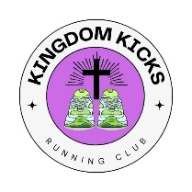

In accordance with the Freedom of Information Act and Protection of Privacy Act, Live Like Liam requires consent to use personal information.
Release of Student Photographs/Name
Live Like Liam requests permission to use photographs/videos/names of participants in a variety of publications to promote Kingdom Kicks. This includes the Live Like Liam website, Facebook page and possibly any online publications (local newspaper/ magazines). This would also include permission for your child to be photographed by the media (TV or newspaper) for events relating to Kingdom Kicks and Live Like Liam.

______ Yes, I give my consent for the publication of my child’s photograph/name and comments for purposes consistent with the above.

______No, I do not permit the publication of my child’s photograph/name and comments for purposes consistent with the above.

Participant Name________________________________
Parent/Guardian Signature___________________________________ Date_______________

